

User Manual [Administrators]

Starting the program

Double-clicking on StockWatch.jar will open the program. A shortcut can also be created for easier access (Right-click > Create shortcut)

Making an Account

After opening the program you will be presented with a login interface. If you do not yet have an account, click ‘New User’ and enter your name, Class Code, and Group Name, as well as your desired password.

When creating an account, make sure:

* the group you are trying to join exists. If you think the group already exists but you still can’t join, close the program and open it again, then try joining the group again or create a new group
* nothing you’ve entered contains a comma. None of the fields will accept anything containing a comma due to the way the data is stored. Also:
  + Your name must be less than 20 character long, recognizable, and not in use. Clicking ‘Check Availability’ will confirm this
  + Password must be between 4 and 30 characters long and should not be your usual password
  + The Class Code and Group Name must have been in ‘Class_List.csv’ and ‘Group_List.csv’ before opening the New User dialog
* 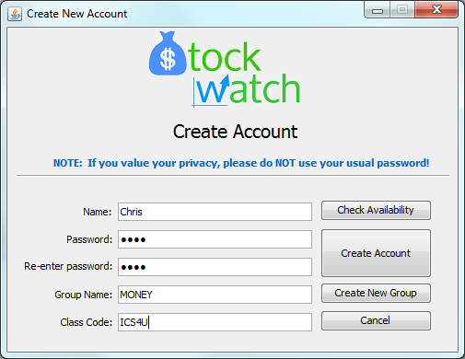You click ‘Create Account’ and then confirm the creation of the account before attempting to log in

Logging In

After creating an account you should be able to enter your name and password to access your group’s watch list. If you’ve forgotten your username or password, ask your teacher to help you retrieve it (or join your group with a new account)

Using the Watch List

After logging in, you will be presented with table listing all of the stocks that people in your group have purchased as well as the amount of money left to spend (remaining funds) and the current worth of your group in the bottom left corner.

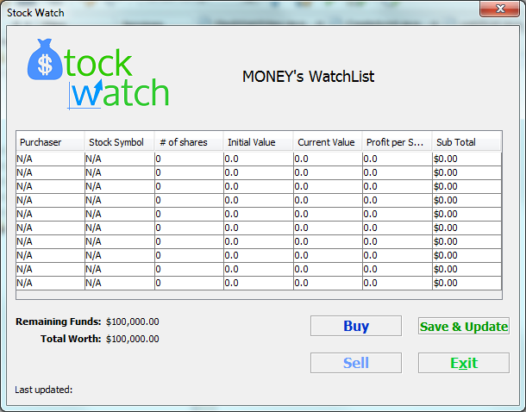

**To buy a stock:** When you know the stock symbol of a stock you’re interested in buying for your group, click ‘Buy’ to add that stock to the watch list. Clicking ‘Save & Update’ will save your stack so that when others in your group click the same button they can see what you’ve just bought.

**To sell a stock**, simply click ‘Sell’ and enter the number of shares you wish to sell. When asked how many stocks you’d like to sell, enter -1 to remove the stock from your watch list – selling all of the stocks you have leaves you with zero of that stock, but it will still appear in your watch list.

**‘Save & Update’** will fetch any stocks that other members in your group have recently bought and check (and if necessary, update) the values of the stocks. This is limited to once every 3 seconds to prevent spamming.

**‘Exit’** will close the program

**NOTE:** If possible, try to avoid buying and selling at the same time as another group member – there is a chance that your purchase will be overwritten! This is also the reason for the restriction on how often you can buy and update the watch list.

Errors

The most common error you will run into will be the overwriting of stocks when two members buy stocks at the same time as each other. However, if you receive error #9001 or #-1337, contact support ([stanleyhu002@gmail.com](mailto:stanleyhu002@gmail.com)), as you likely have an error related to the way the program fetches stock prices and the program will need to be updated. Errors might also be caused by corrupted files or files being accessed at the same time in which case manual editing (see admin manual) and restarting the program respectively should fix the problem.

Admin controls

This program uses .csv (comma-seperated values) to store all of the data inputted by its users. Below is an explanation of how this information is store in case you, as an admin, need to change or fix something.

**NOTE:** Many of these screenshots were taken from the netbeans editor. If editing files in Notepad (not recommended) make sure the new lines are inputted properly. .csv files edited in NetBeans that contain more than one line in the netbeans editor often appear to have only one line when opened in Notepad. To resolve this, try saving the file you intend to edit as blank then pasting the data back in with new lines where appropriate, or, use the netbeans editor (recommended)

Setting up the program

Before running the program, make sure the StockWatch folder is in the appropriate handout drive and that students have permissions to read, read and execute, and write to StockWatch (if not, right click on the folder, click Properties > Edit… and check appropriate boxes for the students group). Also make sure that there is a folder ‘lib’ and another called ‘src’ that contains folders ‘groups’, ‘META-INF’, and ‘stockwatch’ as well as files ‘Class_List.csv’, ‘Group_List.csv’, ‘Login_Info.csv’, and ‘quotesTEMP.csv’. If any of these files or folders are missing you can either manually create them or get them from a backup copy of the program.

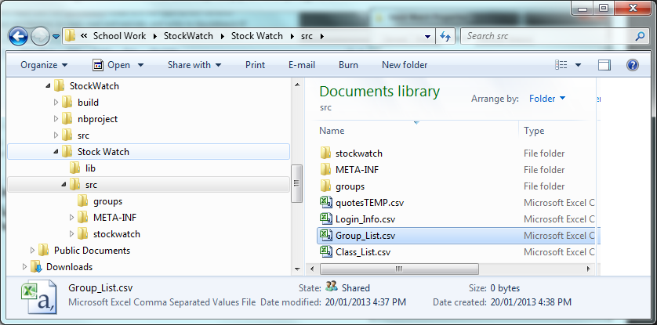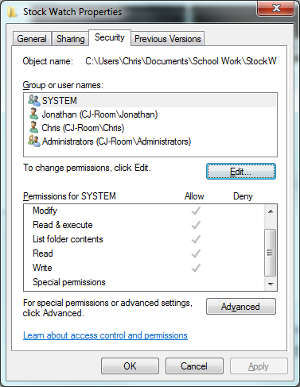

Class_List (Adding a Class)

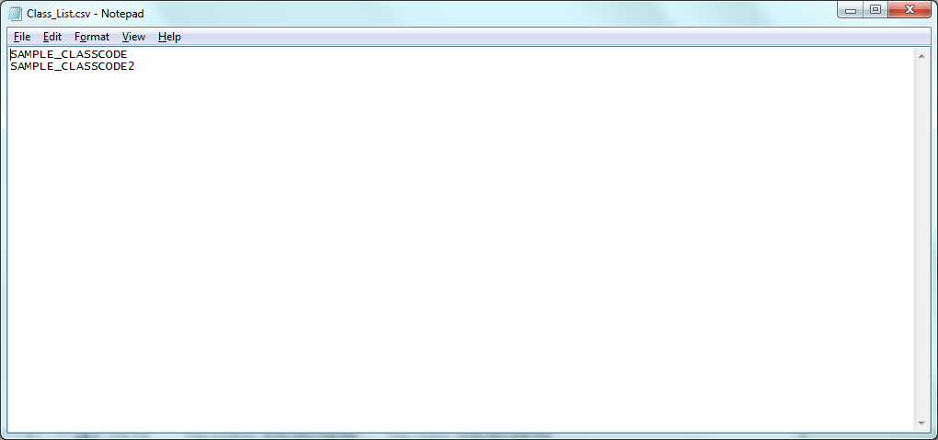Students need a class code to make an account. To create a new class, open Class_List.csv in notepad and add the desired code (no commas!). Make sure there aren’t any blank lines before the first entry or after the last entry.

Group_List (Change group membership)

Holds list of students in each group. Names should agree with the group’s .csv in the groups folder

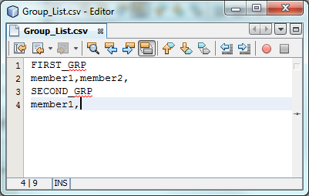

Login_Info (Retrieving account details)

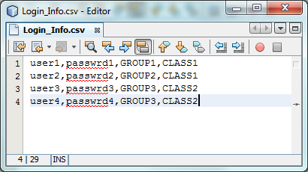Holds list of students’ name, password, group, and class. Users are warned beforehand not to use sensitive passwords!

Group Data (Edit a groups funds/stocks)

Holds a group’s name, “class created by”, funds, and stocks. The brackets and everything in them are only there for clarification and should not be saved to the file.